Authentication & Authorization Guide
Enhancing Security in Messaging Applications
Spinnaker Analytics
26 June 2026

Table of Contents
- Introduction
- Authentication Architecture
- Password-Based Authentication
- Multi-Factor Authentication (MFA)
- Biometric Authentication
- Role-Based Access Control (RBAC)
- Session Management
- Account Recovery & Credential Reset
- Authentication Security Testing
- Security Considerations
- Conclusion

1. Introduction

1.1 Purpose
- This document defines the authentication and authorization mechanisms used to secure access to the messaging application.
- The objective is to ensure that only authorized users can access application resources while protecting user identities, credentials, and session information.

1.2 Objectives
- Strong user authentication
- Multi-factor verification
- Biometric login support
- Fine-grained authorization
- Secure session management
- Account recovery controls
- Protection against credential attacks

2. Authentication Architecture

- Authentication occurs through multiple security layers:
  - Password Verification
  - MFA Verification
  - Biometric Verification (Optional)
  - Session Token Issuance
  - RBAC Authorization

Figure 7 – Authentication Architecture
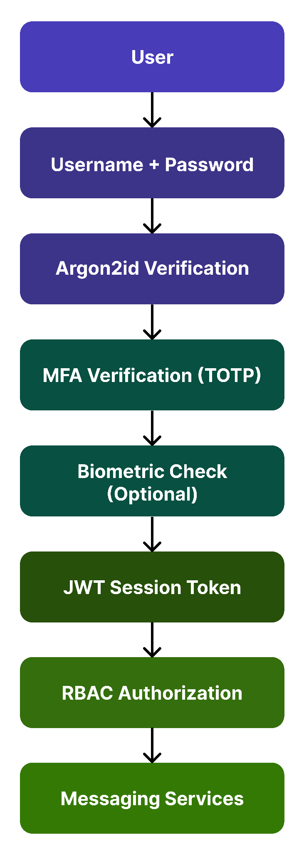

2.1 Authentication Components

Component | Technology
Password Hashing | Argon2id
MFA | TOTP
Biometrics | Android BiometricPrompt
Session Token | JWT
Authorization | RBAC
Transport Security | TLS 1.3

3. Password-Based Authentication

3.1 Password Requirements
Requirement | Value
Minimum Length | 12 Characters
Uppercase | Required
Lowercase | Required
Numeric | Required
Special Character | Required

3.2 Account Lockout Policy

Setting | Value
Failed Attempts | 5
Lockout Duration | 15 Minutes
Progressive Delays | Enabled
Logging | Enabled

3.3 Password Hashing
Algorithm: Argon2id
Configuration:
Parameter | Value
Memory Cost | 64 MB
Iterations | 3
Parallelism | 4
Salt Length | 16 Bytes

3.4 Password Storage Workflow
Figure 8 – Password Processing
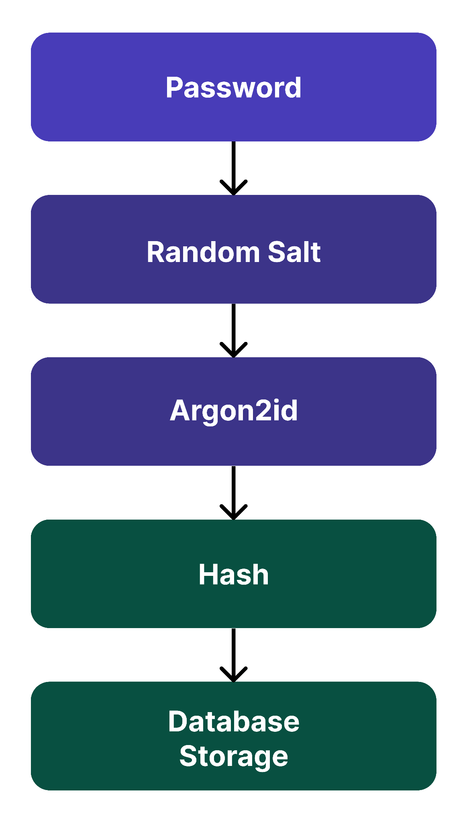

3.5 Security Benefits
- Protection against rainbow tables
- Resistance to brute force attacks
- Unique salted hashes

4. Multi-Factor Authentication (MFA)

4.1 MFA Architecture
- The application uses:
  - Time-Based One-Time Passwords (TOTP)
- Standard:
  - RFC 6238

4.2 Supported Authenticators

Authenticator | Supported
Google Authenticator | Yes
Microsoft Authenticator | Yes
Aegis Authenticator | Yes
Authy | Yes

4.3 MFA Workflow
Figure 9 : MFA Workflow
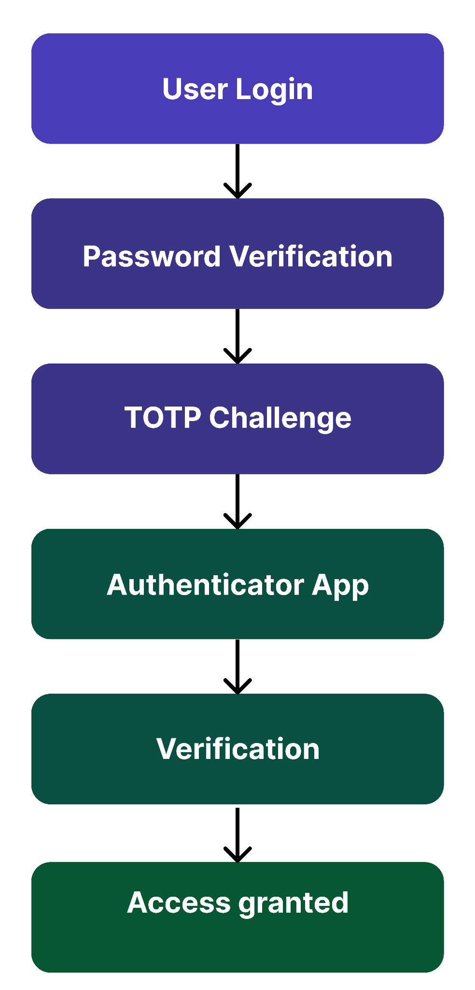

4.4 TOTP Configuration
Parameter | Value
Algorithm | SHA-256
Code Length | 6 Digits
Validity | 30 Seconds

4.5 Authentication Lifecycle Diagram

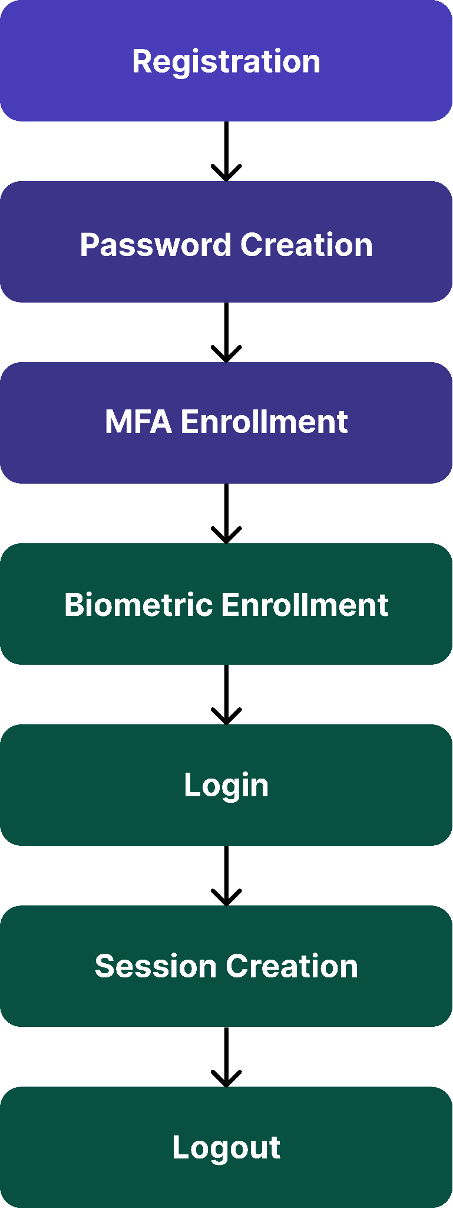

5. Biometric Authentication
- Biometric authentication provides convenience while maintaining strong security.
  - Supported Biometrics
    - Android
      - Fingerprint
      - Face Recognition
    - iOS
      - Face ID
      - Touch ID
Figure 10 – Biometric Authentication Flow
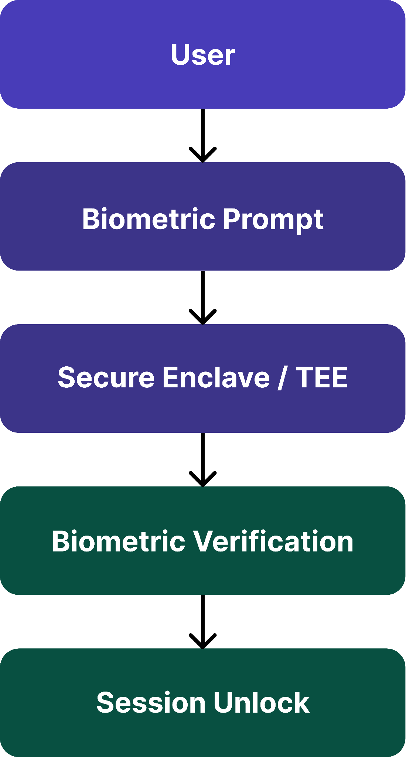
- Security Requirements
  - Biometrics never leave device
  - Templates stored in hardware security module
  - Failed attempts trigger fallback authentication

6. Role-Based Access Control (RBAC)

6.1 Authorization is enforced through RBAC.
- Role Matrix:
Permission | User | Moderator | Admin
Send Messages | Yes | Yes | Yes
Receive Messages | Yes | Yes | Yes
File Transfers | Yes | Yes | Yes
Manage Users | No | Yes | Yes
System Configuration | No | No | Yes
Security Logs | No | No | Yes

Figure 11 – RBAC Authorization Flow
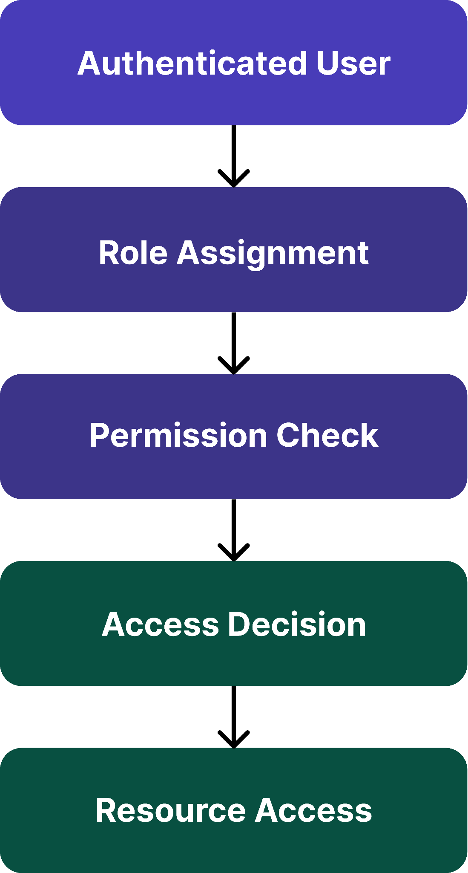

6.2 Principle of Least Privilege
- Users receive only permissions required to perform their functions.

7. Session Management

7.1 Session Creation
- After successful authentication:
  - JWT Token Issued
  - Session ID Generated
  - Secure Cookie Created

7.2 Session Controls
Control | Value
Idle Timeout | 15 Minutes
Maximum Session Duration | 24 Hours
Token Rotation | Every Login
Secure Cookie | Enabled
HttpOnly | Enabled

Figure 12 – Session Lifecycle
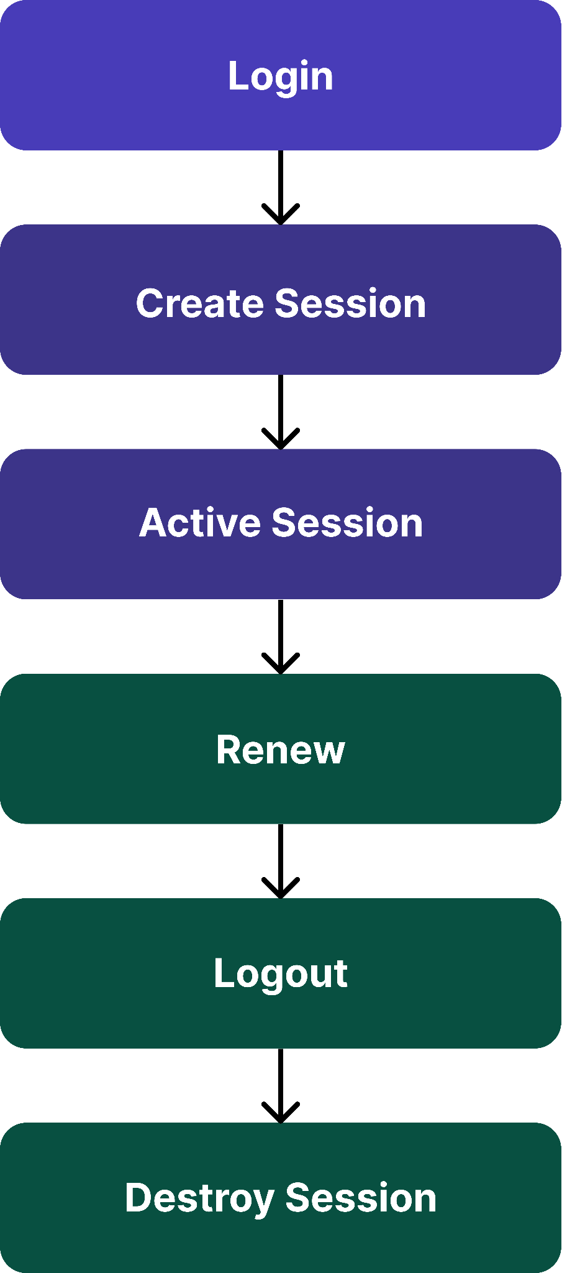

7.3 Session Token Security Table
Token Control | Configuration
Signing Algorithm | RS256
Expiry | 15 Minutes
Refresh Token | Enabled
Rotation | Every Login
Revocation | Supported

7.4 Session Security
- JWT signing
- Secure cookie flags
- Session revocation
- Device tracking

8. Account Recovery & Credential Reset

8.1 Recovery Methods
- Email Verification
  - Recovery link sent to registered email.
- Backup Recovery Codes
  - Generated during MFA enrollment.
Figure 13 – Account Recovery Process
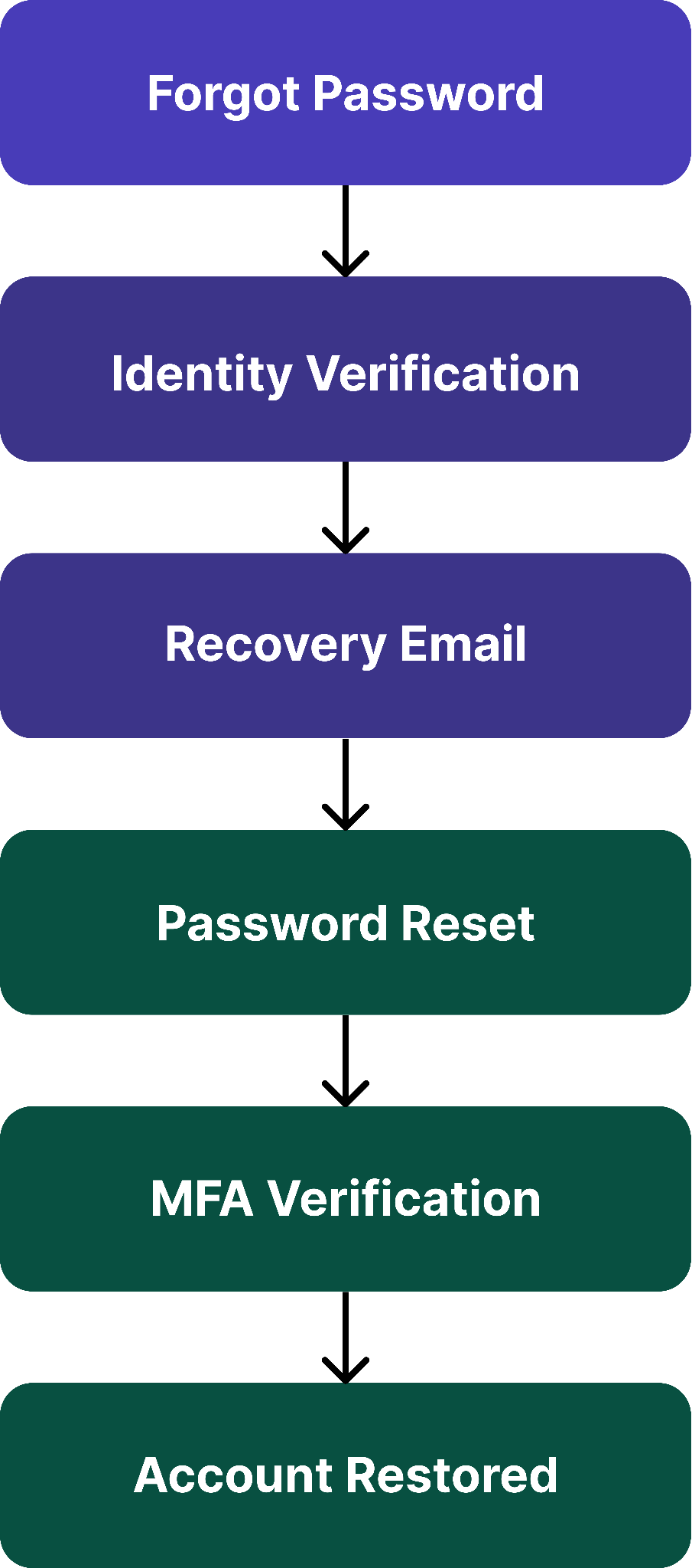

8.2 Security Controls
- Recovery token expiry: 15 minutes
- Single-use recovery links
- Recovery activity logging

9. Authentication Security Testing

9.1 Testing Environment
Tool | Purpose
Burp Suite | Authentication Testing
MobSF | Mobile Security
OWASP ZAP | Session Testing
Frida | Runtime Validation

9.2 Test Cases
Test ID | Test Scenario | Expected Result
AUTH-01 | Invalid Password | Access Denied
AUTH-02 | MFA Failure | Login Blocked
AUTH-03 | Biometric Failure | Fallback Prompt
AUTH-04 | Session Expiration | Reauthentication Required
AUTH-05 | RBAC Violation | Access Denied
AUTH-06 | Password Reset | Verified Recovery

9.3 Validation Objectives
- Verify:
  - Password hashing active
  - MFA enforced
  - Biometric authentication functional
  - RBAC working correctly
  - Session expiration enforced
  - Recovery procedures secure

10. Security Considerations

10.1 Threats & Mitigations

Threat | Mitigation
Credential Stuffing | MFA
Brute Force Attack | Rate Limiting
Session Hijacking | Secure Cookies
Session Fixation | Session Rotation
JWT Theft | Secure Storage
MFA Fatigue | TOTP Only
Privilege Escalation | RBAC
Account Takeover | MFA + Biometrics
Replay Attack | Nonces + TLS

10.2 Security Standards Alignment
Standard | Purpose
NIST SP 800-63B | Authentication
OWASP ASVS | Authentication Controls
OWASP MASVS | Mobile Authentication
RFC 6238 | TOTP
RFC 7519 | JWT

11. Conclusion
- This Authentication & Authorization Guide defines a layered identity security architecture based on:
  - Argon2id password hashing
  - TOTP multi-factor authentication
  - Biometric authentication
  - Role-Based Access Control
  - Secure session management
  - Account recovery protections
- The proposed controls significantly reduce the risk of unauthorized access, credential compromise, account takeover, and privilege escalation while maintaining a secure and user-friendly authentication experience.

